- The Pigeonhole Principle (PHP):

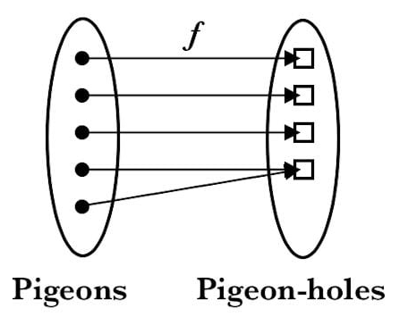

- If k+1 or more pigeons are distributed among k pigeonholes, then at least one pigeonhole contains two or more pigeons.

- For any n numbers, there exist at least two numbers with the same value (a[i] % (n - 1)).

